**DVT discrete V1**

Vcc=5V

Vpower=6V

Legend:

* red: TX+
* yellow: TX-
* green: math TX
* blue: input

**100kHz**

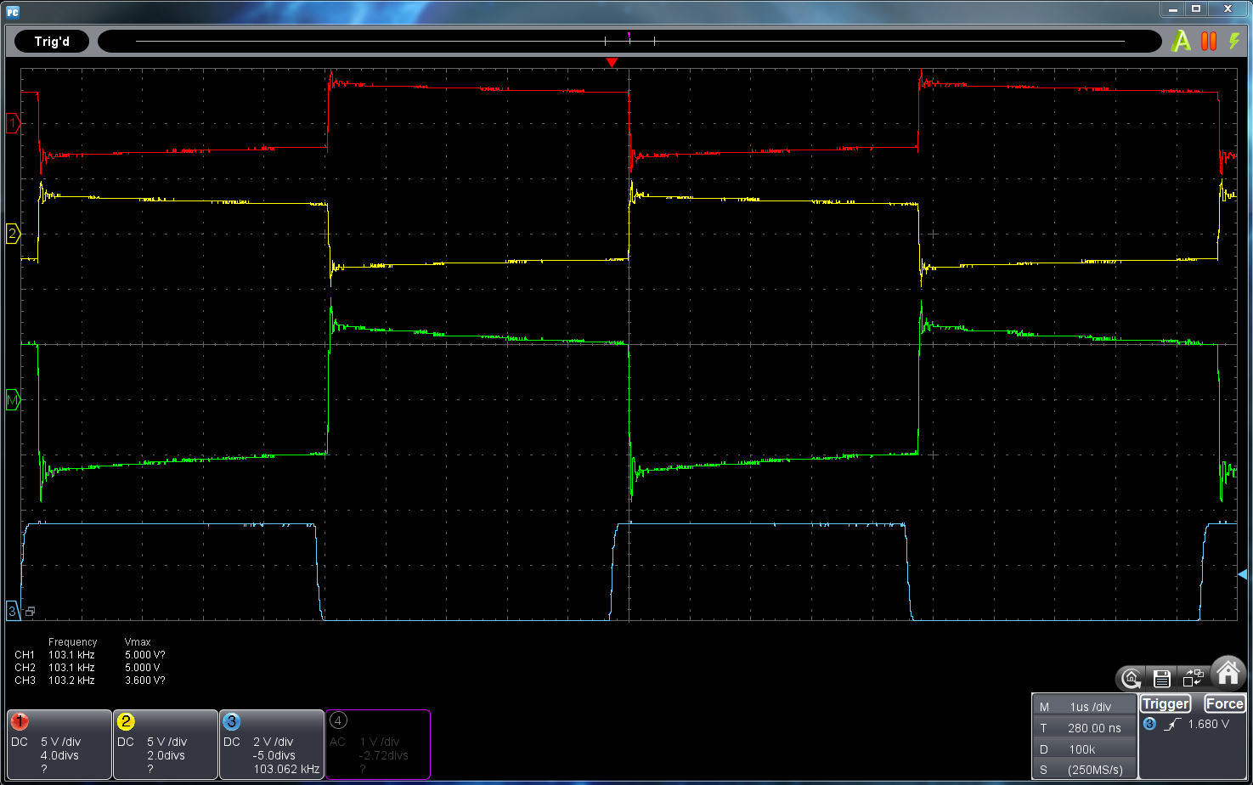

200kHz

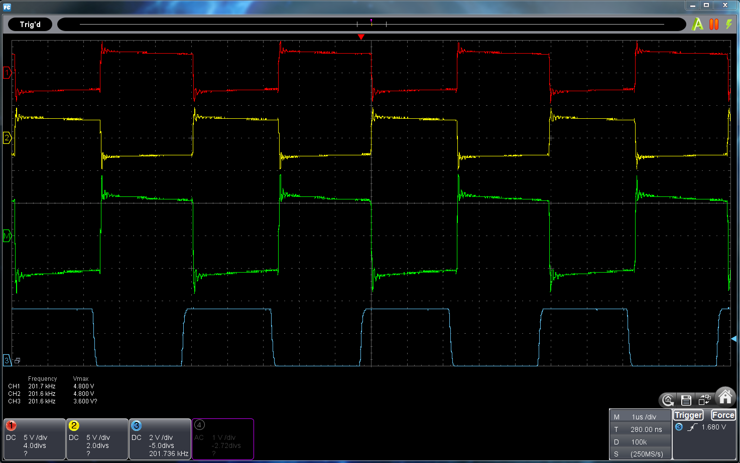

500kHz

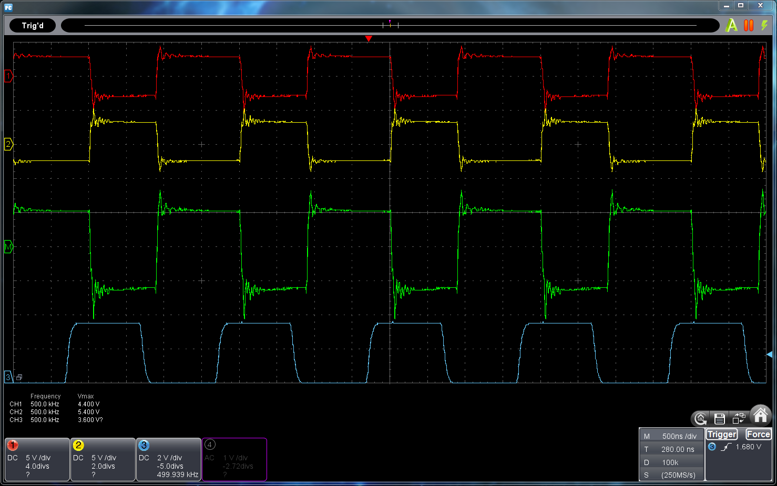

1MHz

